//program using super keyword

class employee {

int wt = 8;

}

class clerk extends employee {

int wt = 10; //work time

void display() {

System.out.println(super.wt); //will print work time of clerk

}

public static void main(String args[]) {

clerk c = new clerk();

c.display();

}

}

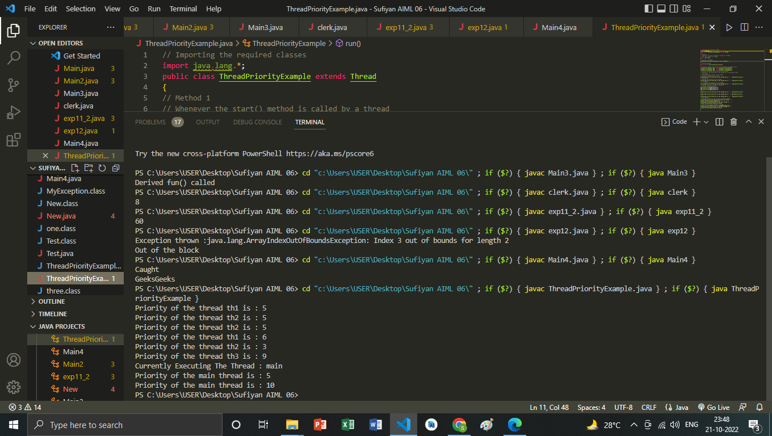

//program on final keyword

import java.util.*;

import java.lang.*;

import java.io.*;

class exp11_2 {

final int val;

exp11_2() {

val = 60;

}

void method() {

System.out.println(val);

}

public static void main(String args[]) {

exp11_2 S1 = new exp11_2();

S1.method();

}

}

